Internet sources for formal wear & accessories

Encore Formal http://www.encoreformal.com/

or
Buy 4 Less Tuxedo http://www.buy4lesstuxedo.com/Tuxedos.html
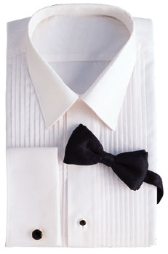  WHITE, 1/4" PLEATS, LAY-DOWN COLLAR, STARTING AT $ 17.95 | 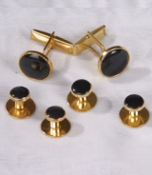  BLACK STUDS WITH CUFFLINKS, STARTING AT $7.95
The District Marshal emphasized strict conformance with the Order’s Official Regalia and Color Corps Dress requirements. Also emphasized was uniformity of the Color Corps dress especially for the upcoming Supreme Convention in August 2010. Items stressed:
- White, tuxedo shirt with lay-down collar & 1/4” pleats
- Black studs without any embellishments
- Black dress shoes, plan in appearance no tennis, walking, hiking types
- Clean, pressed, well fitting tuxedo, cape & chapeaux
- Black bow tie & cummerbund
- Placement of US flag, Official 4th Degree pin and medals of past offices
- Details for the Supreme Convention can be found at http://2010.dcknights.org/attendees/fourth-degree-members?start=1
- Each Color Corps member will undergo 2 detailed inspections prior to any event. Be prepared.

